SQL Murder Mystery: <http://mystery.knightlab.com/>

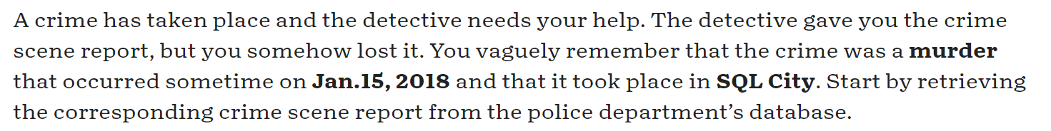

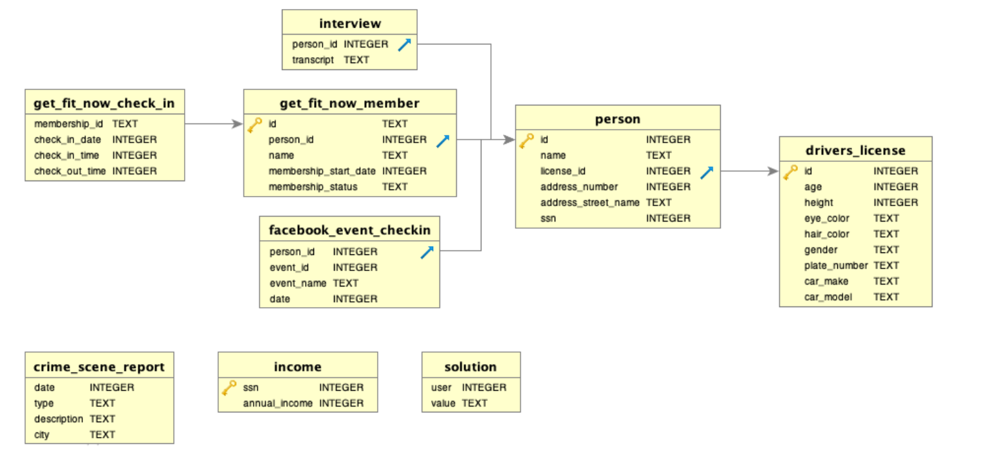

1. Get the crime scene report of the murder on the 15th of January 2018 in SQL City:

SELECT *

FROM crime_scene_report

WHERE type = "murder"

AND city = "SQL City"

AND date = 20180115

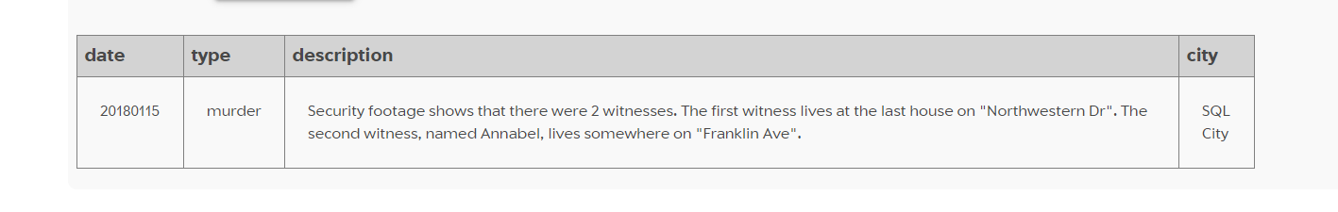

1. The crime scene report describes 2 witnesses. Witnesses: get all people whose address_street_name contains "Northwestern Dr" or "Franklin Ave":

SELECT *

FROM person

WHERE INSTR(address_street_name, "Northwestern")

OR INSTR(address_street_name, "Franklin")

Let’s narrow it down. The 1st witness lives at the last (max address_number) house on Northwestern:

SELECT *

FROM person

WHERE INSTR(address_street_name, "Northwestern")

AND address_number = (

SELECT max(address_number)

FROM person

WHERE INSTR(address_street_name, "Northwestern")

)

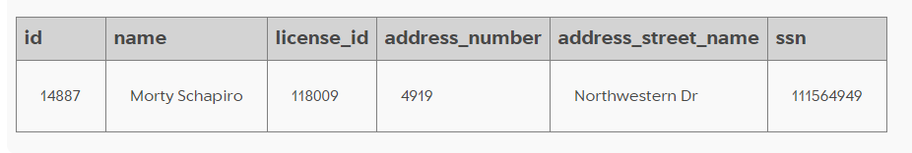

The 2nd witness Annabel lives on Franklin:

SELECT *

FROM person

WHERE INSTR(address_street_name, "Franklin")

AND INSTR(name, "Annabel")

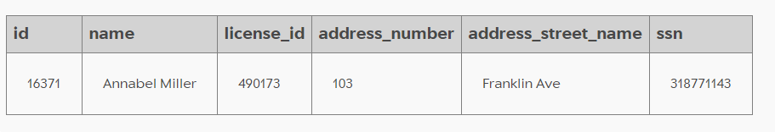

Let’s union the two witnesses into one table:

SELECT *

FROM person

WHERE INSTR(address_street_name, "Northwestern")

AND address_number = (

SELECT max(address_number)

FROM person

WHERE INSTR(address_street_name, "Northwestern")

)

UNION

SELECT *

FROM person

WHERE INSTR(address_street_name, "Franklin")

AND INSTR(name, "Annabel")

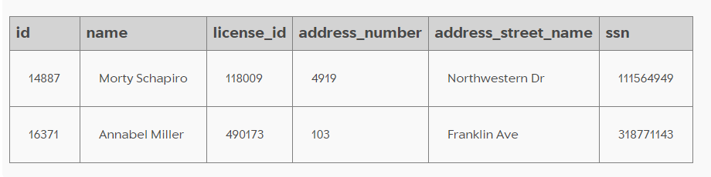

1. Now that we have the two witnesses, let’s take a look at their interviews to see if we can get any more information about the murderer:

SELECT *

FROM interview

WHERE person_id IN (

SELECT id

FROM person

WHERE INSTR(address_street_name, "Northwestern")

AND address_number = (

SELECT max(address_number)

FROM person

WHERE INSTR(address_street_name, "Northwestern")

)

UNION

SELECT id

FROM person

WHERE INSTR(address_street_name, "Franklin")

AND INSTR(name, "Annabel")

)

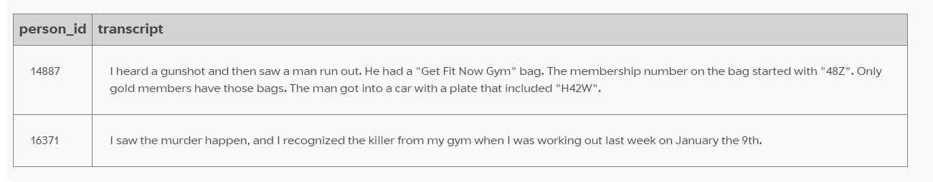

1. From the witness interviews, the killer works out at the "Get Fit Now Gym". The killer's membership number starts with 48Z. They are a gold member.

SELECT *

FROM get_fit_now_member

JOIN person ON person.id = get_fit_now_member.person_id

WHERE membership_status = "gold"

AND INSTR(get_fit_now_member.id, "48Z")

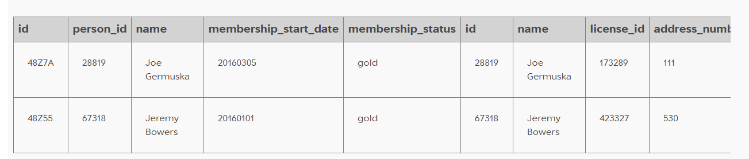

1. This leaves us with 2 possible people from the gym's data who could be the killer. The killer's license plate includes H42W.

SELECT *

FROM get_fit_now_member

JOIN person ON person.id = get_fit_now_member.person_id

JOIN drivers_license ON drivers_license.id = person.license_id

WHERE membership_status = "gold"

AND INSTR(get_fit_now_member.id, "48Z")

AND INSTR(plate_number, "H42W")

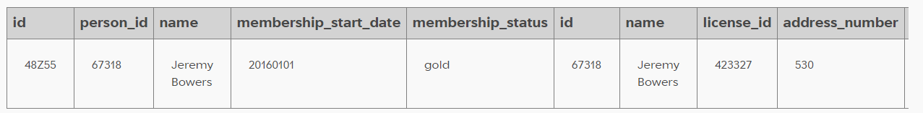

1. From this we can see that the only possible suspect with all these details is the person by the name of Jeremy Bowers (person_id # 67318). Let's check the solution...

INSERT INTO solution VALUES (1, 'Jeremy Bowers');

SELECT value FROM solution;

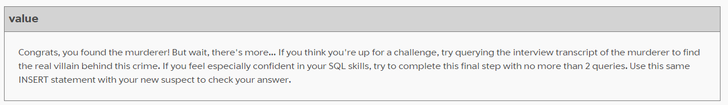

1. Turns out there's more to this story... let's get Jeremy Bowers' interview transcript.

SELECT *

FROM interview

WHERE person_id = 67318

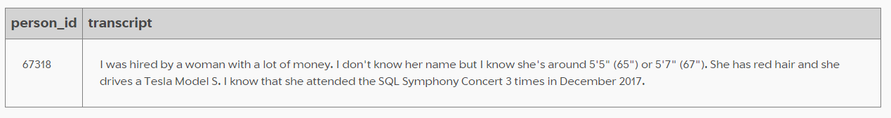

1. Jeremy was only the hit man! The payer is a woman with a large income, is between 65" and 67" in height, has red hair, drives a Tesla Model S. She attended the SQL Symphony Concert 3 times in December 2017. Let's first get people who match the physical description:

SELECT *

FROM person

JOIN drivers_license ON drivers_license.id = person.license_id

WHERE hair_color = "red"

AND car_make = "Tesla"

AND car_model = "Model S"

AND height < 67

AND height > 65

AND gender = "female"

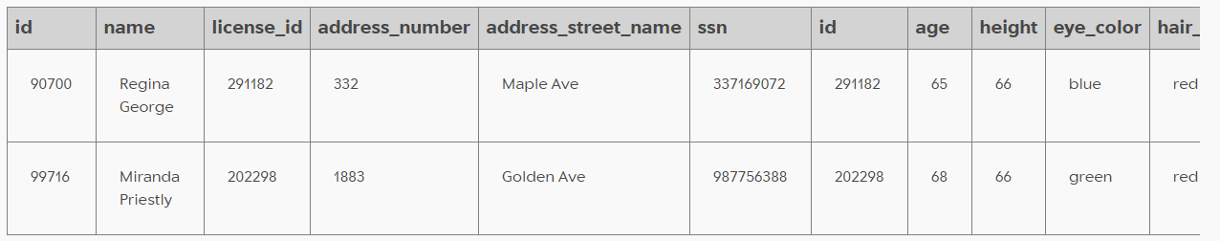

1. Let's see if one of them has a large income

SELECT *

FROM person

JOIN drivers_license ON drivers_license.id = person.license_id

JOIN income ON income.ssn = person.ssn

WHERE hair_color = "red"

AND car_make = "Tesla"

AND car_model = "Model S"

AND height < 67

AND height > 65

AND gender = "female"

ORDER BY annual_income DESC

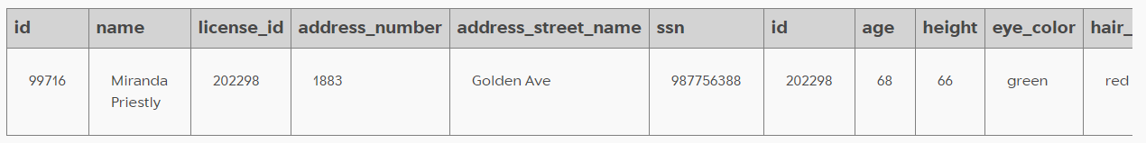

1. We only have data for the income of one of the 2 suspects who match the physical description. Miranda Priestly has a relatively large annual income of $310k. However, let's not rule out the other suspect. Let's first check if either of the two has been to the SQL Symphony concert 3 times in December 2017:

SELECT *

FROM facebook_event_checkin

WHERE INSTR(CAST (date AS text), "201712")

AND event_name = "SQL Symphony Concert"

AND person_id IN (

SELECT person.id

FROM person

JOIN drivers_license ON drivers_license.id = person.license_id

WHERE hair_color = "red"

AND car_make = "Tesla"

AND car_model = "Model S"

AND height < 67

AND height > 65

AND gender = "female"

)

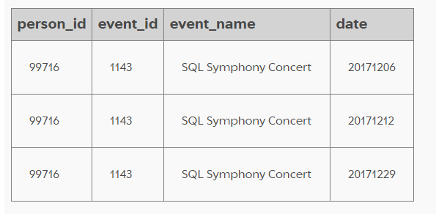

1. The only person who went to the concert 3 times in December 2017 is the person by the ID of 99716, who again has the name of Miranda Priestly. We solved it!

INSERT INTO solution VALUES (1, 'Miranda Priestly');

SELECT value FROM solution;

